FACULTY PROFILE
Name | P. Rohini | 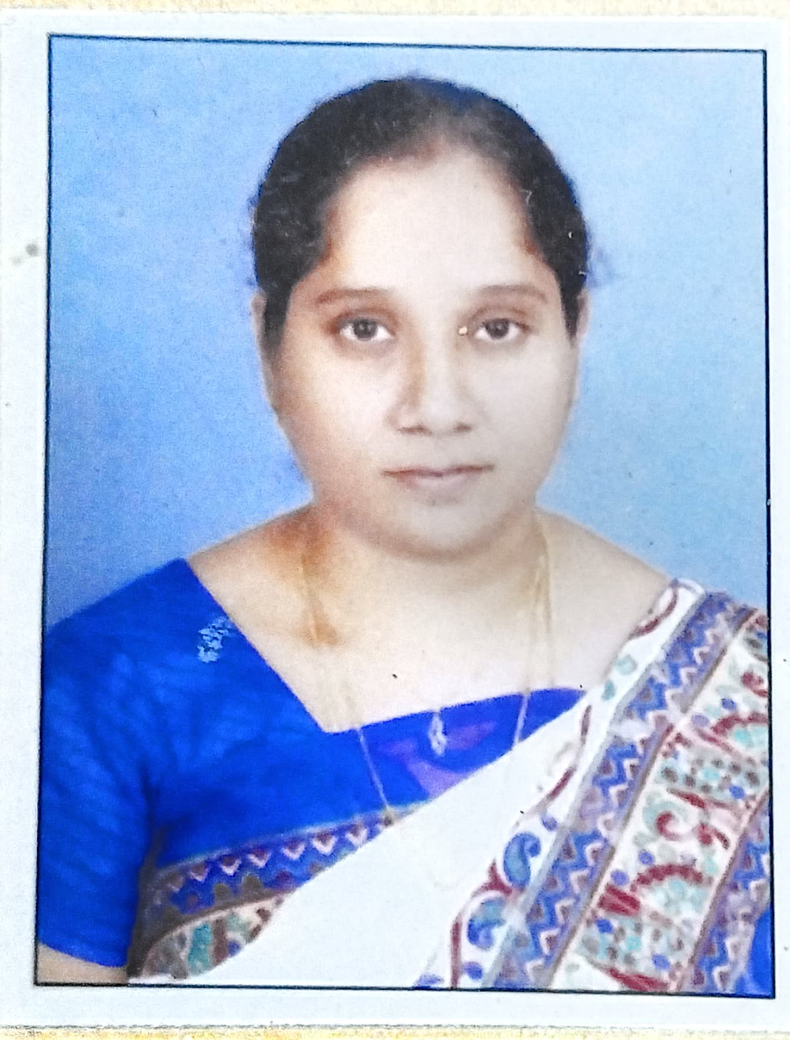
Department | Department of English
Designation | Lecturer in English (Contract)
Date of Appointment | 12/07/2007
Date of Birth | 10/06/1981
Contact Number | 8374941079
Email Id | prohini010@gmail.com
Academic qualifications:
Qualification | Name of the University | Year of passing
Ph. D
M.SC/M.A/M.COM | M.A.English Acharya Nagarjuna University | April 2004
Others Qualifications (NET/SET etc.), if Any
Experience Details:
Designation | Name of the Institution, Place | From | To
Lecturer in English (Contract) | GDC Rapur, Nellore dt | 2007 | 2010
Lecturer in English (Contract) | GDC Kovur, Nellore dt | 2010 | 2013
Lecturer in English (Contract) | DK GCW Nellore | 2013 | 2014
Lecturer in English (Contract) | Y.A.GDC W Chirala Prakasam dt | 2014 | 2015
Lecturer in English (Contract | TRR GDC Kandukur Prakasam dt | 2015 | 2016
Lecturer in English (Contract | GCW(A) Guntur | 2016 | 2021
Lecturer in English (Contract | Y.A.GDC W Chirala Prakasam dt | 2022 | 2022
Lecturer in English (Contract | GDC Dornala Prakasam dt | 2022 | 2023
Lecturer in English (Contract | SVA GDC (M) Srikalahasti Tirupati dt | 2023 | 2024
Total Teaching Experience: P.G Classes: __2__Years
U.G Classes: ___17____Years.
Research Experience Including Years spent in M.Phil/Ph.D:
Fields of Specializations under the subject/Discipline:
a.
b.
List of research Publications/Books:
Title of the Paper | Journal | Year of Publishing | UGC CARE/SCI/SCOPUS etc.
List of Projects Completed:
Title of the Project | Sponsoring Agency | Major/Minor | Total Grant Received | Year of Completion
List of OC/RC/TOTs/FDP/MOOCS/ARPIT Attended:
Title of the course | Type of the Course (FDP/RC Etc.) | Duration | Organized by
Microsoft Diversity Training Programme | FDP | 5 Days | APITA
Training of the Trainer's Programme | FDP | 1 Day | UNESCO - MGIEP & CCE
Training Programme on NEP 2020 Sensitisation and Orientation. | FDP | 9 Days | S.V.University
Co-Curricular, Extension and Professional Development Related Activities:
S.No | Name of the Activity | Details
1 | Student related Co- Curricular, extension and field-based activities (such as extension work through NSS/NCC and other channels, Cultural activities, subject related events and counseling.
2 | Contribution in corporate life and management of the department and participation in academic and administrative committees and responsibilities and Professional Development.
Awards/ Achievements: Please give details of any other credentials, significant contributions, awards received:
S.No | Name of the Award/Achievement | Date of Receiving
1

