**Drive Details 2018-19 to 2022-23**

|  |  |  |  |
| --- | --- | --- | --- |
| **Year** | **Date of the drive** | **Name of the company** | **No. of students selected** |
| 2018-19 | 04.04.18 | TVSTS | 49 |
| 05.02.2019 | Alcance Technologies | 8 |
| 25.02.2019 | Flextronics Pvt. Ltd., Sricity | 37 |
| 2019-20 | 31.7.2019 | Big Basket, Polaris, KIA , INDIGO, RSMIPL | 35 |
| 08.01.2020 | Honda, TATA Foods India Pvt. Ltd, NS Instruments Pvt. Ltd | 40 |
| 10.03.2020 | RSMIPL, TILL HEALTHCARE, KELLOGGS INDIA Pvt. Ltd | 22 |
| 2020-21 | 23-3-2021 | Fox Link | 34 |
| 2021-22 | 23.11.21 | Apollo Pharmacies Ltd. | 36 |
| 23.12.21 | Bharath FIH(Raising Star Mobile ) | 29 |
| 2022-23 | 12.7.2022 | Dixon & Bharath FIH(Raising Star Mobile ) | 24 |
| 18.8.2022 | ICICI | 03 |
| 18.10.22  SRR & CVR College,Vijayawada | Om Logistics | 01 |
| 07.12.22 | TCL (TTE) | 22 |

**Online Courses 2021-22 & 22-23**

2021-22 Micro soft Up skilling 24 registered in various degree Programmes 28 students got certificate

2022-23 22 Micro soft Up skilling 32 registered in various degree Programmes course is going on

28 candidates got certificates in MTP Course

**Training Details**

|  |  |  |  |
| --- | --- | --- | --- |
| **S.No** | **Skill** | **No. Of Hrs Allotted** | **Trainer** |
| **1** | ***Communication Skills*** | 60 Hrs | Guest English Mentor (GEM) |
| **2** | ***Soft Skills*** | 30 Hrs  10 Hrs | Guest English Mentor (GEM) |
| **3** | Ethical Values | weekend classes | Guest English Mentor (GEM) |
| **4** | ***Analytical Skills*** | **60Hrs** | Fulltime Mentor working on contract basis |
| **5** | ***Technical Skills*** | **60Hrs** | Fulltime Mentor working on contract basis |
| **6** | ***General Awareness*** | **30Hrs** | Fulltime Mentor working on contract basis |
|  | ***Total*** | **250 hrs training package** | |

**2018-19 Drive Photos**

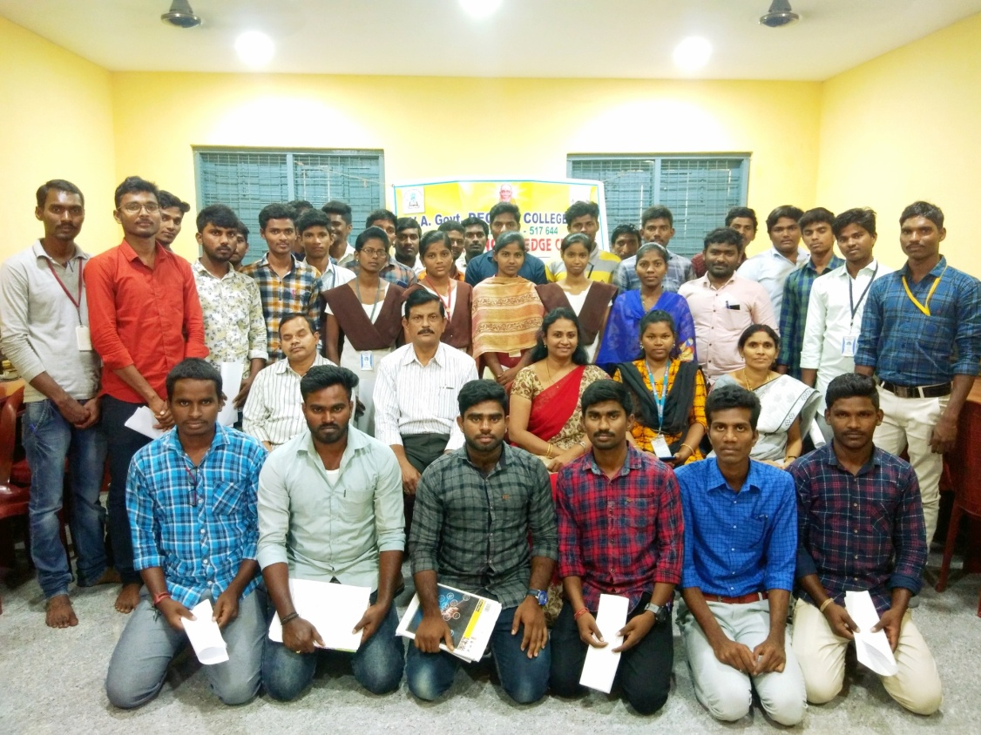

Flextronics Pvt. Ltd., Sricity 25.02.2019

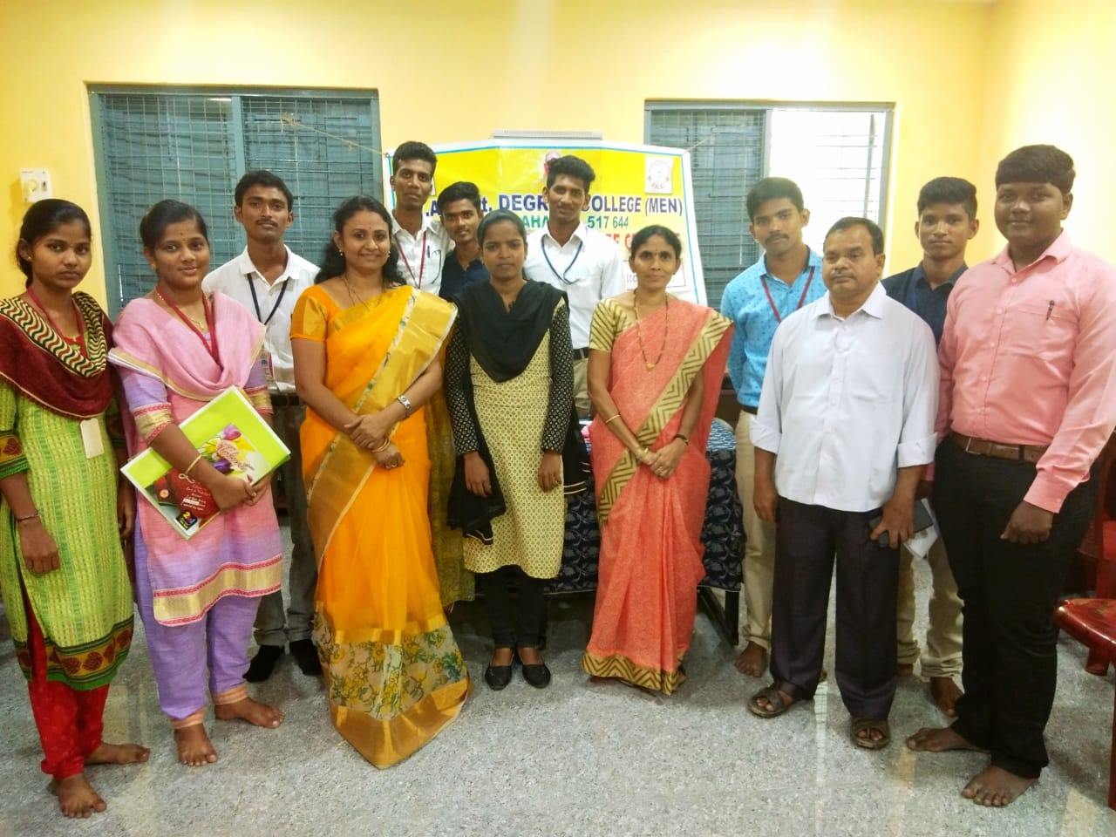

**Alcance Technologies Campus Drive on 05.02.2019**

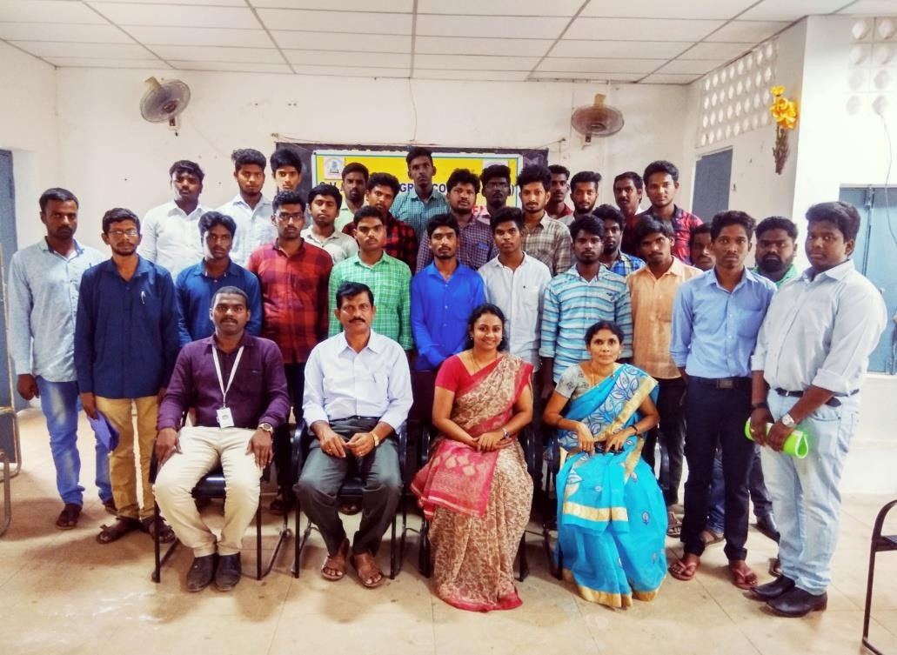

**TVSTS Off Campus Drive on 04.04.18**

**2019-20 Drive Photos**

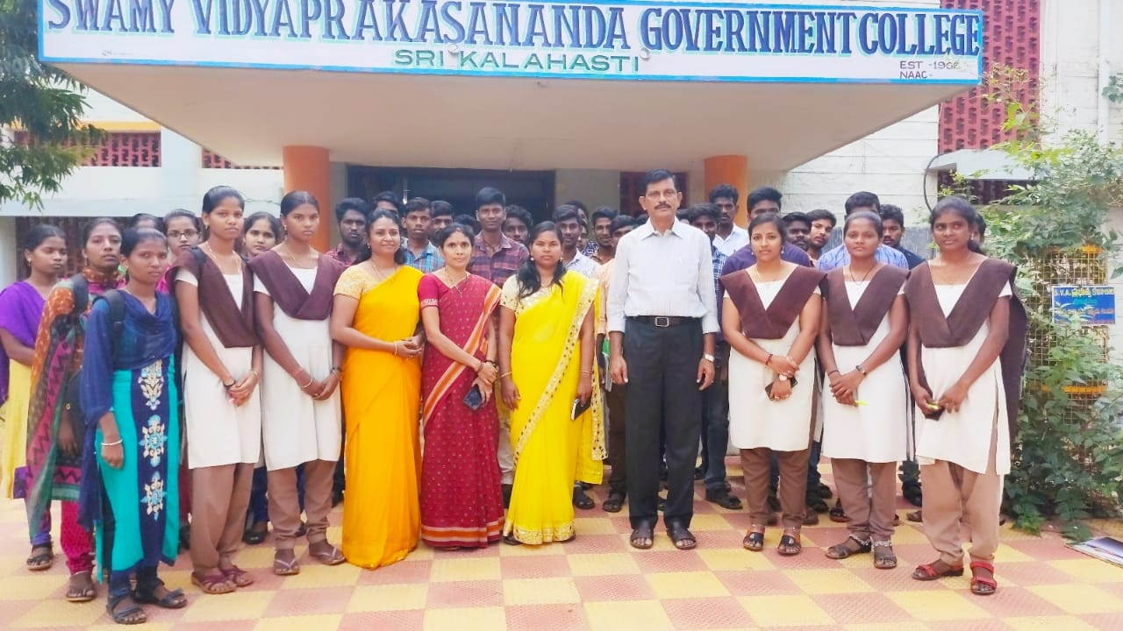

Honda, TATA Foods India Pvt. Ltd, NS Instruments Pvt. Ltd 08.01.2020

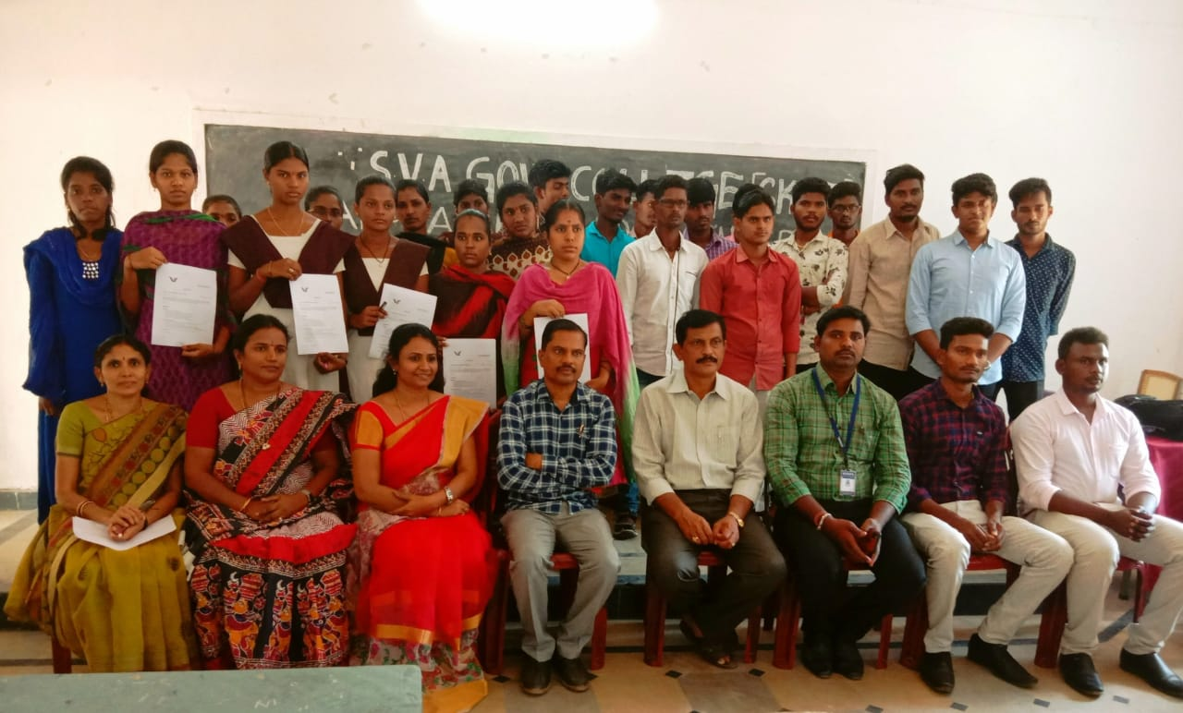

RSMIPL, TILL HEALTHCARE, KELLOGGS INDIA Pvt. Ltd 10.03.2020

**2020-21 Drive Photos**

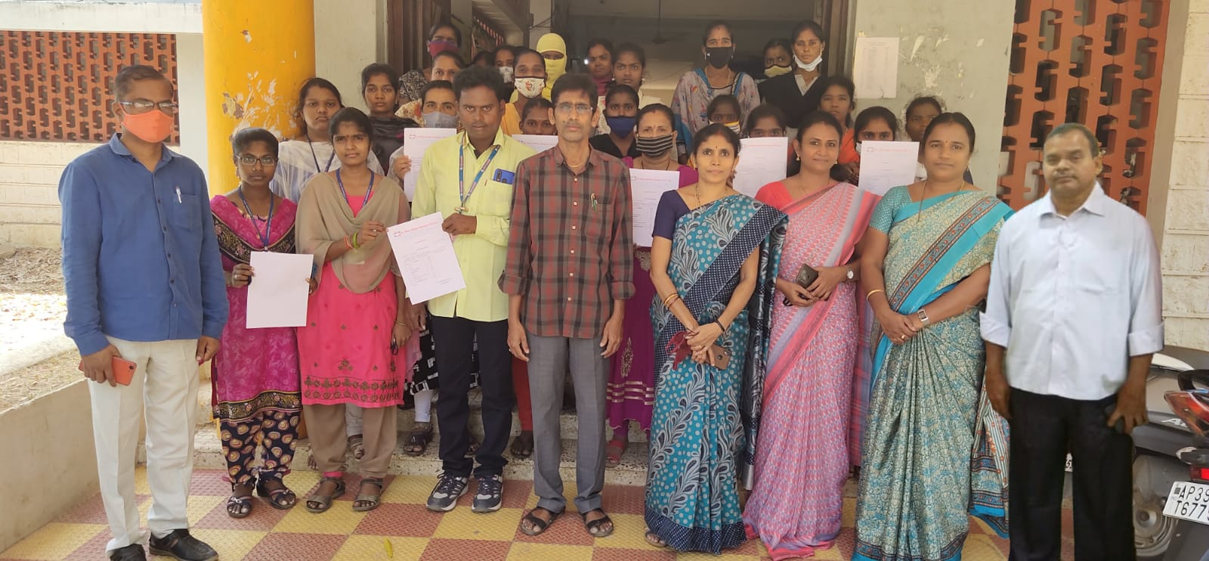

**FOX LINK Off Campus Drive 23.03.2021**

**2021-22 Drive Photos**

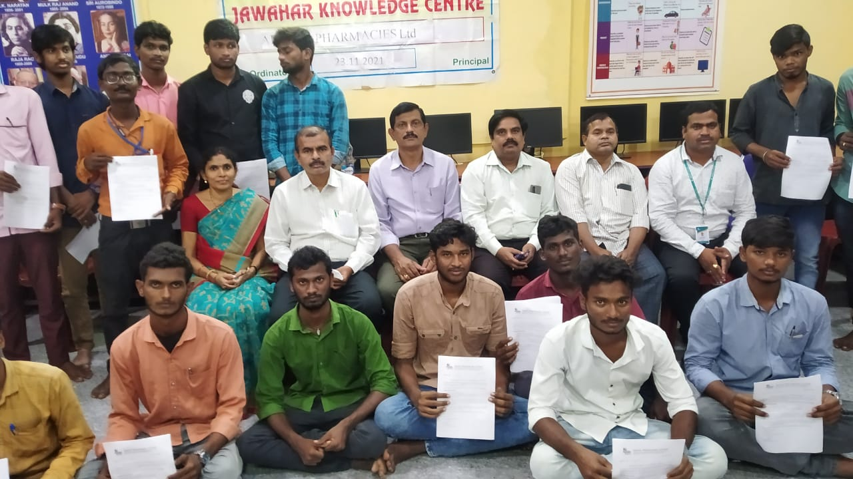

**Apollo Pharmacies Ltd 23.11.2021**

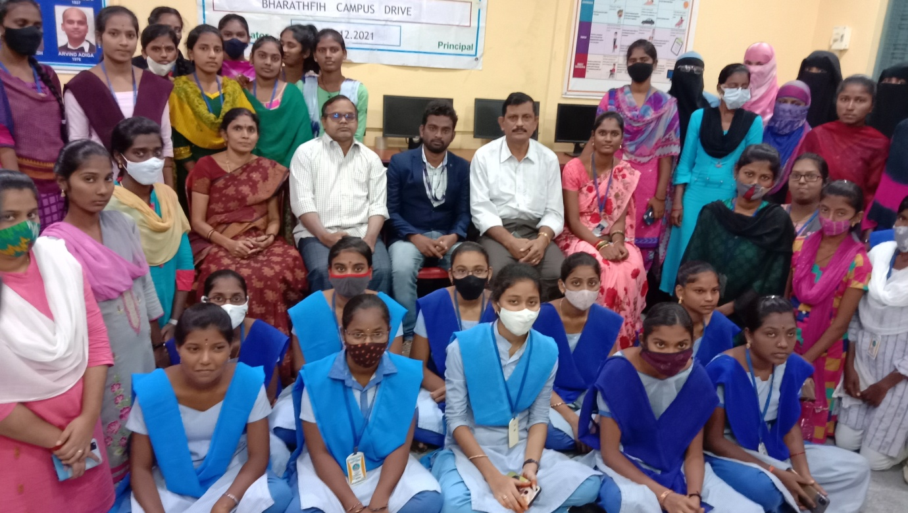

**BHARATH FIH OFF CAMPUS DRIVE 23.12.2021**

**2022-23 Drive Photos**

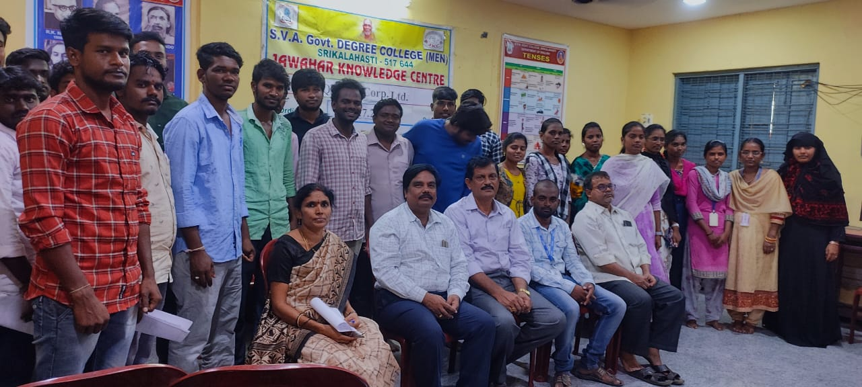

**Quess Corp Ltd., 12.07.2022**

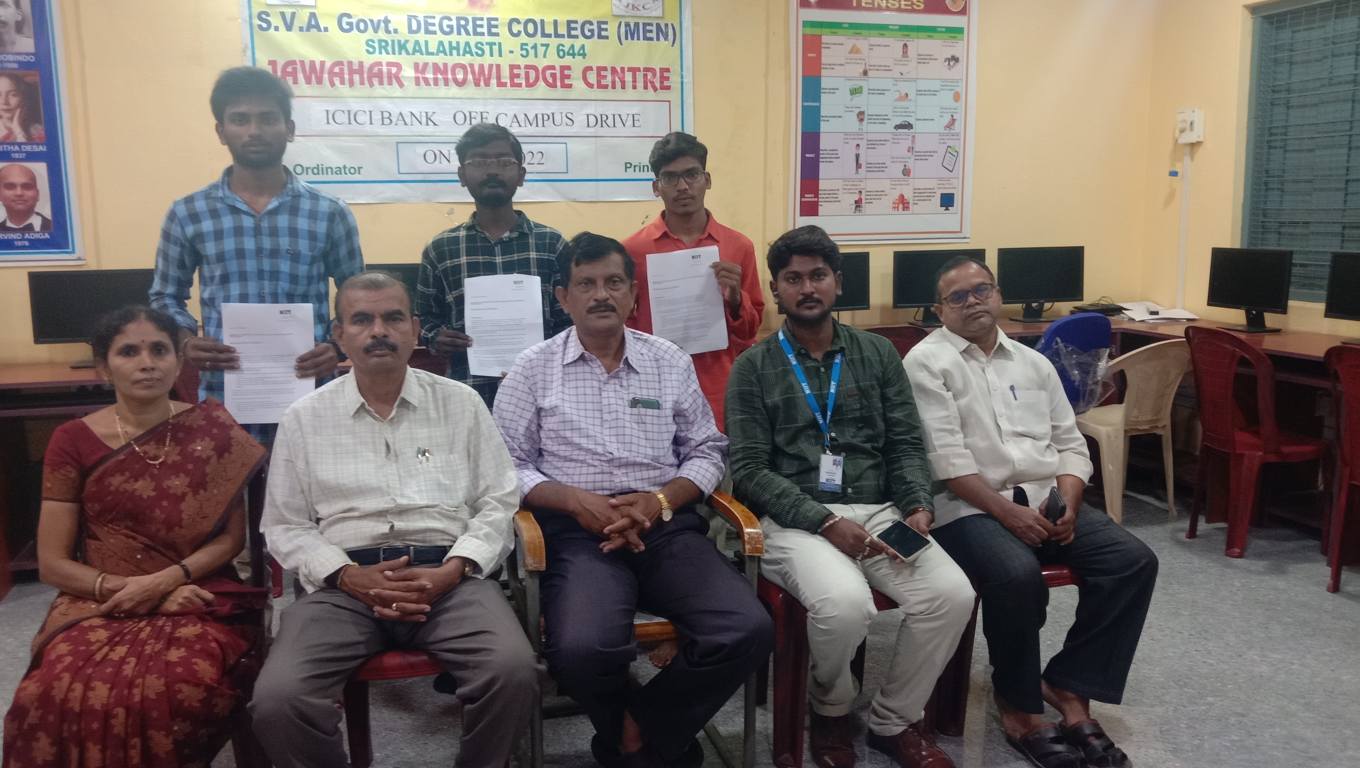

**ICICI OFF CAMPUS DRIVE on 18.08.2022**

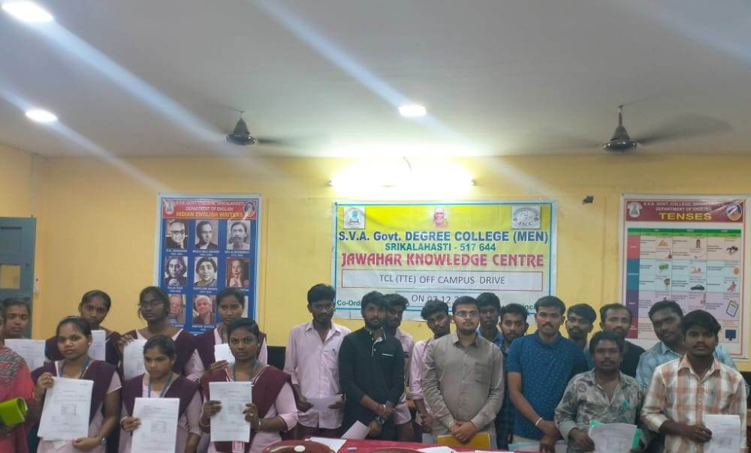

TCL (TTE) CAMPUS DRIVE **O**N 07.12.22